VILLAGE OF GARLAND
Regular Meeting Agenda – December 3rd, 2024 – 7pm
- Pledge:
    - Call meeting to order/roll call
    - All board meetings are recorded
- November 5th Minutes,
- Claims
- Bryce Standley resignation of 2 yr term
- Installation of new Trustees, Bryce Standley, Todd Strauss and Emmanuel Morales
    - Oath of Office
- Trustee Officers
    - Board Chair
    - Chair Pro Tem
    - Street Commissioner
    - Utilities Commissioner
    - Parks, Recreation and Grounds Commissioner
- Introduce Appointment Resolution 2024-06, waive 3 separate readings
    - Clerk, Wayne Regnier
    - Law Enforcement, County Sheriff
    - Attorney, Hoffschneider Law
    - Engineer, Miller & Assoc.
    - Street Superintendent,Reed Miller of Miller $ Assoc.
    - Banking, Cattle Bank
    - Newspaper, Seward County Independent
    - Posting locations, Bulletin boards by mail boxes and Fire Hall, Village Hall door
- Clerk and Maintenance Report
- Old Business:
    - ARPA update
    - Survey Record at ballfield
    - NDEE loan extension
    - Bricks and Mortar Grant
    - Allo box locations
    - GBE Village Accountant
- Water Wastewater Operator
- Maintenance Position
- Introduce Village Board Pay Resolution No. 2024-07, waive 3 separate readings
- Fire Department Budget: Nicole Wegman
- Ballfield Usage/Rental
- Water bill consumption
- Seward County Update
- Adjournment.

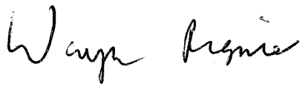_________________________________________
Wayne Regnier, Village Clerk

