VILLAGE OF GARLAND
Regular Meeting Agenda – February 4th, 2025 – 7pm
- Pledge:
    - Call meeting to order/roll call
    - All board meetings are recorded
- January 7th Minutes,
- Village Claims
- Fire Department Claims and Report
- Clerk and Maintenance Report
- Appointment of Haley Hackbart, to the remaining 2 yr Board Trustee seat
- Viking Water Tower Maintenance, John Reimer
- Village Attorney status
    - Eric Fern, Keating O’Gara Law
- Fire Department report
- Planning, Zoning ordinances for ETJ
- Credit Card Resolution, 2025-2
    - Possible waive 3 reading
    - Possible approval
- Kiwanis Club, after school program
- Trustee Commissioners
    - Grants Commissioner
    - Street Commissioner
    - Utilities Commissioner
    - Parks, Recreation and Grounds Commissioner
    - Planning, Zoning Commissioner
    - Health and Safety Commissioner
- Old Business:
    - Survey Record at ballfield, proposal
    - Fire Hall Rental
    - NDEE loan extension
    - Allo box locations
    - 4th & Frazier Traffic, Recommendation from Miller & Associates
    - Water Wastewater Operator, expanded needs of the job for the ad. Full time or part-time, back up, experience, what are the needs?
    - Insurance Loss: Water Tower Camera Proposal
    - Village Insurance
    - NextLink Contract
    - Water bill percentage late fee. penalties and resolution
- Planning Commission
- Seward County Update
- Public Comment
- Announcements
    - Next Board Meeting is March 4th 2025
- Adjournment.

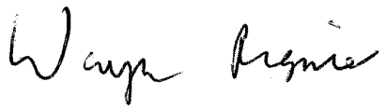_________________________________________
Wayne Regnier, Village Clerk

