VILLAGE OF GARLAND
Regular Meeting Agenda – January 7th, 2025 – 7pm
- Pledge:
    - Call meeting to order/roll call
    - All board meetings are recorded
- December 3rd Minutes,
- Claims
- Public Comment
- Clerk and Maintenance Report
    - Lawyer contacts, Clerk and or the Board only
    - Water tower, future contract
- Fire Dept Report
    - Jones Bank Signatory, Bryce Standley
    - Jones Bank view only status for GBE Accounting
- Trustee Commissioners
    - Street Commissioner
    - Utilities Commissioner
    - Parks, Recreation and Grounds Commissioner
    - Planning, Zoning Commissioner
    - Health and Safety Commissioner
- Old Business:
    - ARPA update, added JR Trenching $1,525
    - Survey Record at ballfield, proposal
    - NDEE loan extension
    - Bricks and Mortar Grant, turned down
    - Allo box locations
    - Ballfield contract, Hoffschneider Law has contract
    - Board Trustee opening
    - Water Wastewater Operator
- 4th and Frazier Traffic
10. Seward County Roads, Old Mill Rd project
    - Burn site
11. Water Tower Camera Insurance Loss and Replacement
12. Nextlink Contract
13. Insurance Policy
14. Delinquent utility bills
15. Bulk Water Resolution 2025-1
    - Waive 3 readings
16. Fire Hall Rental @ $50
17. Seward County Update
18. Adjournment.

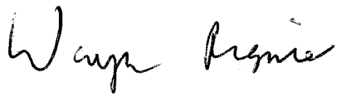_________________________________________
Wayne Regnier, Village Clerk

