VILLAGE OF GARLAND
Regular Meeting Agenda – March 4th, 2025 – 7pm
- Pledge:
    - Call meeting to order/roll call
    - All board meetings are recorded
- February 4th Minutes,
- Village Claims
- Fire Department Claims and Report
- Appointment of Haley Hackbart, to the remaining 2 yr Board Trustee seat
- Kiwanis Club, after school program
- Dakota Aquifer, UNL Geologist
- ETJ Zoning, adoption of ordinances
- Village Attorney Report
    - 4 way stop, ordinance
    - Fire department by-laws
    - Contracts
NextLink
Garland Youth Sports
- Viking Water Tower Maintenance
- Village Maintenance Position
- Old Business:
    - Survey Record, Allen Surveying
    - Mike Luebbe 30 to 10 % update
    - Water Wastewater Operator back up opening
    - Insurance Loss: Water Tower Camera Proposal
    - Village Insurance, LARM
    - Water bill 10 percent late fee. penalties
    - Planning Commission, Appointments
- Seward County Update
- Clerk and Maintenance Report
- Public Comment
- Announcements
    - Next Board Meeting is April 1st 2025
- Adjournment.

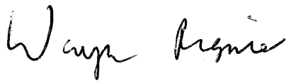_________________________________________
Wayne Regnier, Village Clerk

